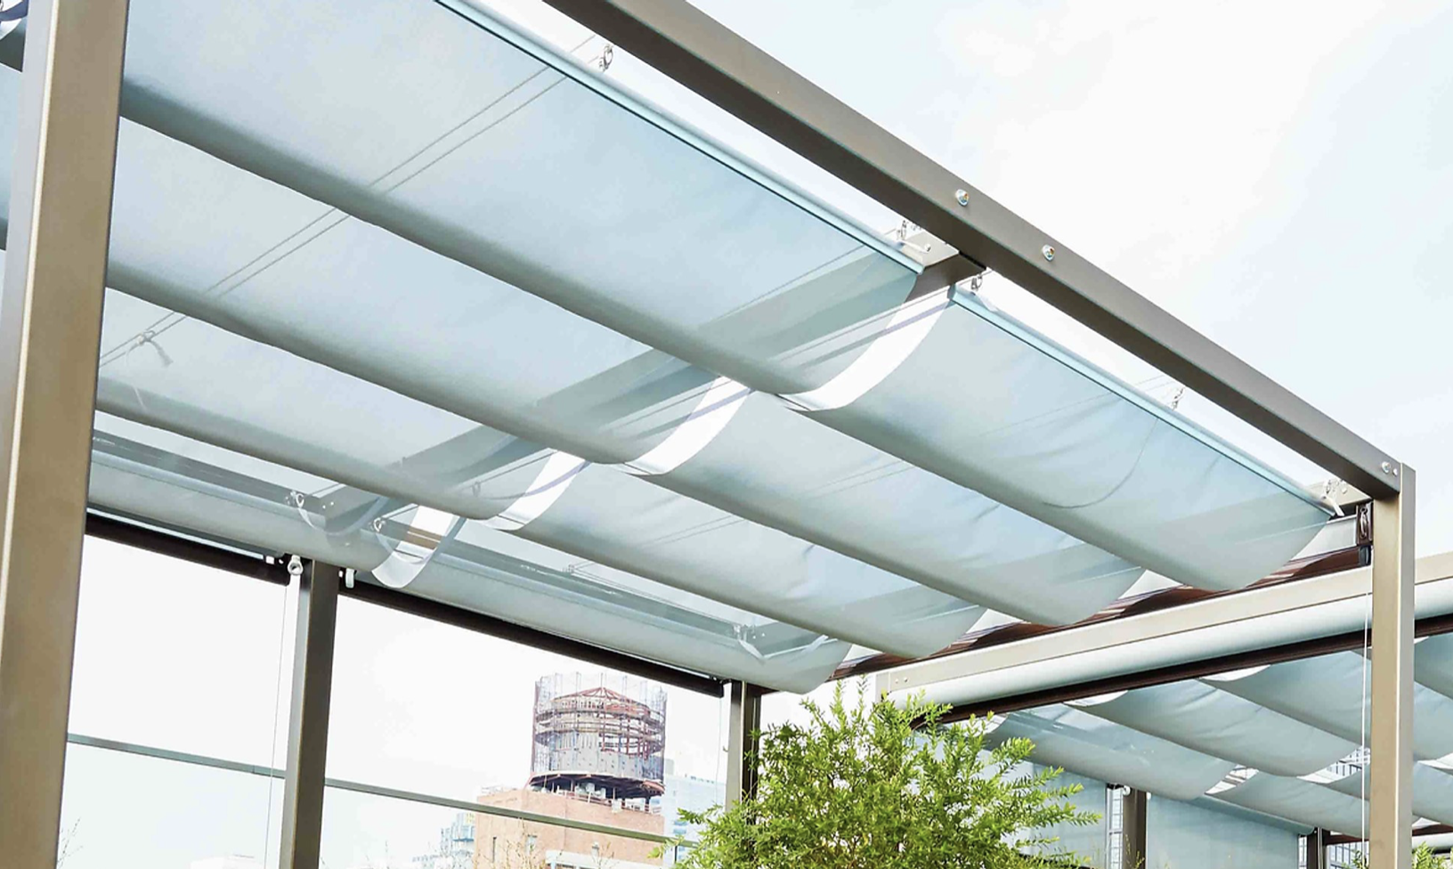

SECTION 10 73 19 – OPERABLE FABRIC CANOPIES

This section includes editing notes to assist the user in editing the section to suit project requirements. These notes are included as hidden text, and can be revealed or hidden by the following method in Microsoft Word:

Display the FILE tab on the ribbon, click OPTIONS, then DISPLAY. Select of deselect HIDDEN TEXT.

- GENERAL

  - ADMINISTRATIVE REQUIREMENTS

    - Pre-Installation Conference:
      - Attendance: [Architect,] [Owner,] [Contractor,] [Construction Manager,] installer, and related trades.
      - Review: Project conditions, manufacturer requirements, delivery and storage, staging and sequencing, and protection of completed work.

  - SUBMITTALS

    - Action Submittals:
      - Shop Drawings: Illustrate products, installation, and relationship to adjacent construction.
      - Product Data: Manufacturer’s descriptive data and product attributes for metal panels and underlayment.
      - Samples: [Selection samples.] [Verification samples.]

    - Closeout Submittals:
      - Operation and Maintenance Data.

  - QUALITY ASSURANCE

    - Installer Qualifications: Minimum [2] [__] years’ experience in work of this Section.

    - Mockup: Minimum [4 x 8] [__ x __] feet.

  - WARRANTY

    - Manufacturer’s 5 year warranty against defects in materials and workmanship.

- PRODUCTS

  - MANUFACTURERS

    - Contract Documents are based on products by Infinity Canopy. www.infinitycanopy.com.

    - Substitutions: Refer to Division 01.

  - COMPONENTS

    - System Description:
      - Suspended individual fabric panels supported by pair of cables drawn between any two points.
      - Fabric design: [One color.] [Multiple colors.] [Custom logo.]
      - Fabric opens and closes from either direction, controlling fabric flatness and bellowing.
      - Panels individually removable for replacement or to allow for ventilation.
      - Bellow control: Adjustable bracing limit tape to set bellow distance and fabric protection.

    - Fabric:
      - Source: [____] by [____] [or approved substitute].
      - Type: [____].
      - Transparency: [____].
      - Ultraviolet blocking: [____].
      - Fire hazard classification: [____], tested to [ASTM E84.] [NFPA 701.]
      - Configuration: [To be selected by Design Professional.] [Manufacturer’s standard.]

    - Frames:
      - 6063 aluminum, clear anodized finish, double sided grooved track with end caps.
      - Detachable and sliding fabric panels fit into bottom frame track and adjustable hardware on top track.

    - Hardware:
      - Material: Series 316 stainless steel.
      - Fabric clips: Placed anywhere along frame top track, with wheels for smooth movement.
      - Allow for 360 degree rotation.
      - Spring-loaded gate for attachment and detachment from carrying cables.
      - Sharp tips to allow for penetration of limit tape and affixation of limit tape to canopy frame.

    - Cables: Type 316 stainless steel aircraft cable, diameter and construction to suit canopy size and conditions.

    - Operation: [Individual pull cords.] [Magnetic latch.] [Pulley and rope.]

**** OR ****

    - Motorized Operation:
      - System type: As recommended by canopy manufacturer; sized to canopy conditions.
      - Controls: [Wall mounted switch.] [Handheld remote,] [Controlled by app.] [Connect to building automation system.]

  - ACCESSORIES

    - Fasteners: Type 316 stainless steel, type best suited to application.

- EXECUTION

  - INSTALLATION

    - Install in accordance with manufacturer’s instructions and approved Shop Drawings.

    - Locate controls [____.] [where directed.]

  - ADJUSTING

    - Adjust canopies for smooth operation and bellow lengths [as directed by Design Professional.] [in accordance with manufacturer’s instructions.]

END OF SECTION

